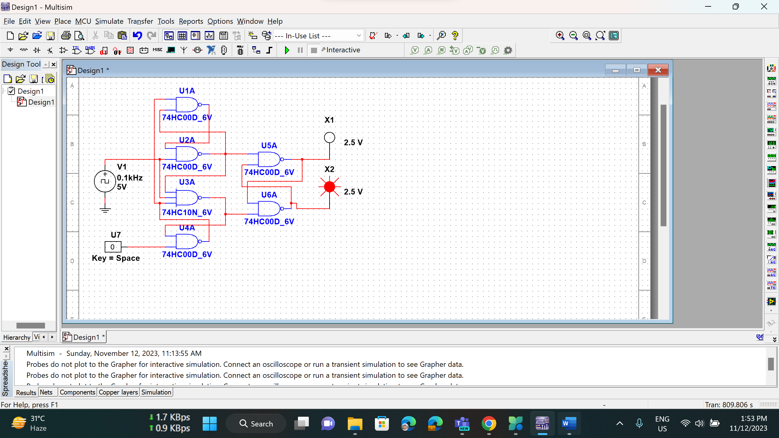

**Figure-1:** Simulation for logic circuit of a positive edge triggered D flip-flop without preset and clear capability.

**Figure-2:** Simulation for logic circuit of a positive edge triggered D flip-flop with preset (active low) and asynchronous clear (active low) capability.